8 GPT Alternatives

This chapter covers
- Jurassic by AI21
- Claude by Anthropic
- Coral by Cohere
- Bard by Google
- Huggingface’s models
Please ignore grammar errors and typos. What you see is a raw manuscript; it has not been copyedited.
Time to meet some of GPT’s “friends”! So far, we have been focusing on GPT and other OpenAI models. But OpenAI is not the only game in town. Quite on the the contrary, we are currently witnessing a “Cambrian explosion” of language models with new models popping up every week. Before using language models in production, you want to make sure that you’re using the very best model for your task. In this chapter, we’ll have a look at many of the OpenAI alternatives out there and discuss the pros and cons of different models as well as how to use them.
Almost all language models nowadays are based on a similar architecture, namely the Transformer architecture (have a look at Chapter 3 for details). However, models from different providers may differ by the way they are trained, by the way they represent text, or by the way in which they are offered and priced. All of those factors can make a difference in terms of processing fees and output quality for your specific task. Models like GPT are powerful and solve almost any task. But this generality comes at a cost: if a small, specialized model is available, trained for just the task you’re interested in, using such a model may very well be the optimal choice.
One thing that you will notice throughout the following sections is that many of the models we discuss can be accessed via similar interfaces to OpenAI. That’s good news for you: no need to get into a novel and complex framework, each time that you want to try a different model! And with that, let’s start our exploration of GPT alternatives.

Why is my favorite model not listed?
If your favorite model or model provider is not listed in the following, don’t panic! With the growing number of providers and models, it has become impossible to give a full overview of available models. If a model is not listed here, it does not mean that it couldn’t be the best alternative for your task! As the interfaces of different providers tend to be similar, you should still be able to use what you learned so far in order to employ other models without much trouble. Also note that we list model providers in alphabetical order in the following. Don’t infer any priority from that (e.g., we’re not discussing the best providers first!).

8.1 AI21
AI21, founded in 2017, offers a variety of Cloud-hosted language models. Those models come in different sizes and with different specializations. AI21’s largest and more generic model, the Jurassic-2 model, is available since recently and we will try it out in the following. You can find more details on Jurassic-1, the direct predecessor, in a corresponding whitepaper. Among other things, AI21 uses a fairly large vocabulary of tokens, compared to other language models. Why does it matter? Because pricing for AI21 (as well as other providers) is typically based on the number of tokens processed. If we have a larger vocabulary of tokens, we can afford to represent even less frequently used words by a single tokens (whereas we might need to use a combination of tokens when using a smaller vocabulary). That means we can represent the same text with fewer tokens and pay a smaller fee. Of course, fees depend not only on the number of tokens but also on the price per token. But it’s good to keep in mind that a lower price per token does not automatically translate into lower processing fees. Testing out a few samples is a better way to compare processing fees.

8.1.1 Chatting with Jurassic
Let’s have a chat with Jurassic-2! Why AI21 relates its newest models to dinosaurs is up to anyone’s guess but the model performance is anything but pre-historic! Go to AI21’s homepage at https://www.ai21.com/. You should see the screen depicted in Figure 8.1. Click on the button in the right upper corner, marked up in Figure 8.1. You may have to create an account when logging in for the first time. If so, follow the instructions (which include providing an email address and a phone number). After that, you should see the screen depicted in Figure 8.2.

Figure 8.1 Homepage of AI21 (https://www.ai21.com/): click on the button in the right upper corner to try their language models.
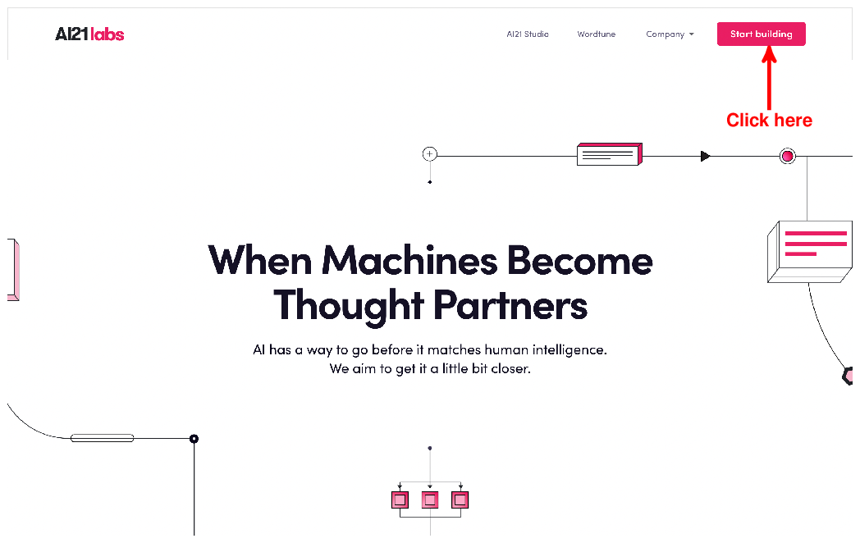

Up - understood
Note the three categories here: examples, specialized models, and foundation models. As discussed at the start of this section, AI21 offers several specialized models for tasks such as summarization or question answering. We will discuss more about those models in the following subsection. But, for now, let’s use the biggest model available. Click on the button labeled “Foundation Models” (marked up by the arrow in Figure 8.2) to see a list of Jurassic-2 variants.

Figure 8.2 To get a first impression of AI21’s capabilities, click on the button labeled “Foundation Models”.
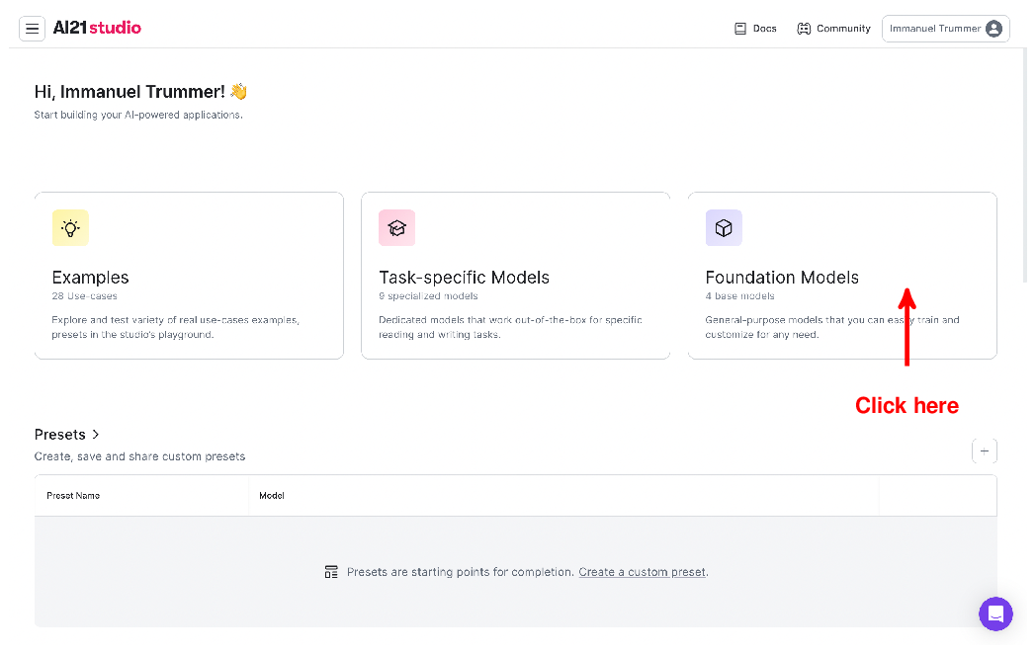

Up – understood.
After that, you should see the screen depicted in Figure 8.3. Similar to OpenAI’s GPT models, the Jurassic-2 model comes in different sizes (reaching, at the time of writing, from light to “Ultra”, i.e., the largest model variants). This means you can get faster (and cheaper) results when being willing to trade in a bit of quality (even though, for your specific task, it may not actually matter, enabling you to save money without compromising on result quality). For the moment, let’s use the “Brachiosaurus” among the Jurassic-2 variants (my last reference to dinosaurs in this section, I promise) and click on the button marked up in Figure 8.3.

Figure 8.3 Click on the button labeled “Playground” to chat with AI21’s Jurassic model.
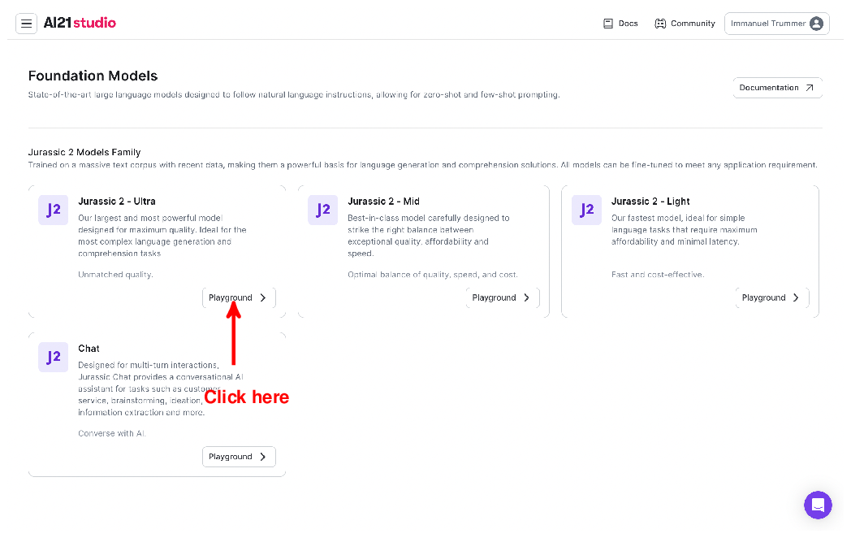

Up -understood.
This will lead you to the Web interface, shown in Figure 8.4. Looks familiar? If you have been using OpenAI’s Web interface for a while, it should not take too long to familiarize yourself with this one as well. Simply enter your prompt in the text box above (that’s where it says “Enter a prompt here” in Figure 8.4) and click on the button below (also marked up in Figure 8.4) to generate an answer! You can try all the prompts we sent to GPT in Chapter 2 and whatever else you’re interested in. What similarities and differences do you observe?

Figure 8.4 Web interface for chatting with AI21’s Jurassic model: enter a prompt in the field above and click on the button below to generate an answer.
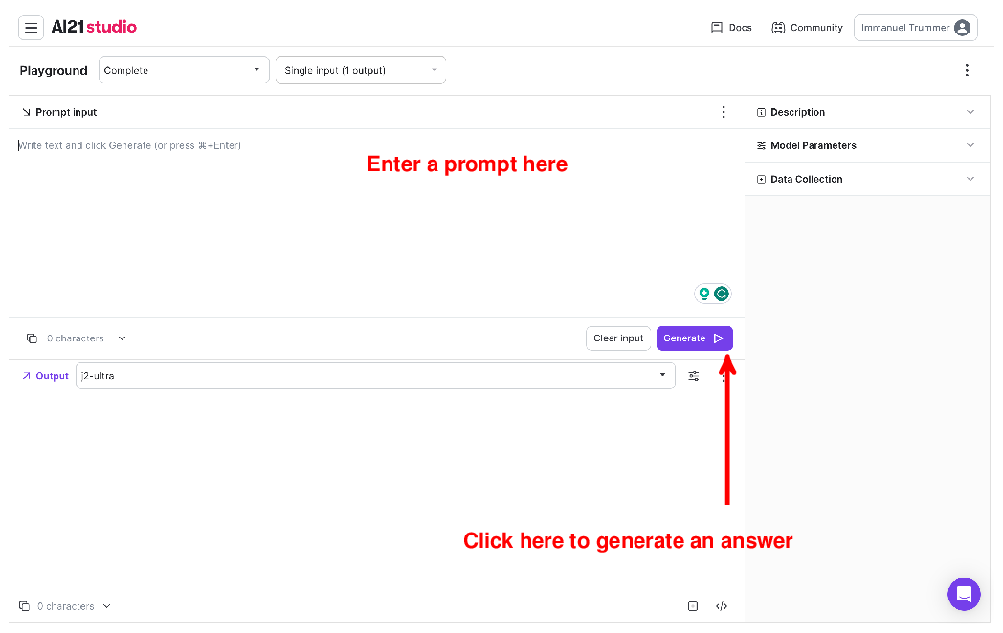

Screens I encountered were different but after fumbling around was able to set model, submit a prompt, and get a reasonable, if the interface has changed, the content should be updated to reflect these changes; otherwise forewarn readers of possible interface and use Google if any help is needed.

8.1.2 Python API
Entering text by hand won’t cut it if we want to analyze large amounts of data. The Web interface is great for getting a first sense of Jurassic’s capabilities but comes with limitations. Fortunately, AI21, similar to other providers, offers a dedicated Python API to call its language models. First of all, install the library by running the following commands in your terminal:
pip install ai21==1.3
copy
To use AI21’s models from Python, we first have to import the library we just installed:
import ai21
copy
Then, you know the drill, we’ll have to configure AI21 with an access code. This access code connects your requests to an account, enabling AI21 to bill you properly. No worries though: after signing up for AI21, you should receive a credit that enables you to run the following examples without setting up billing. You find the API key by logging into the AI21 Website, then clicking on your profile name in the right upper corner and on “API key” in the corresponding drop-down menu (see Figure 8.5). After retrieving your key, configure access in Python by running the following code (substitute the three dots with your actual AI21 access key):
ai21.api_key = ...
copy

Figure 8.5 Retrieve your access key for using AI21 via the Python API by clicking on the “API key” item in the drop-down menu above.
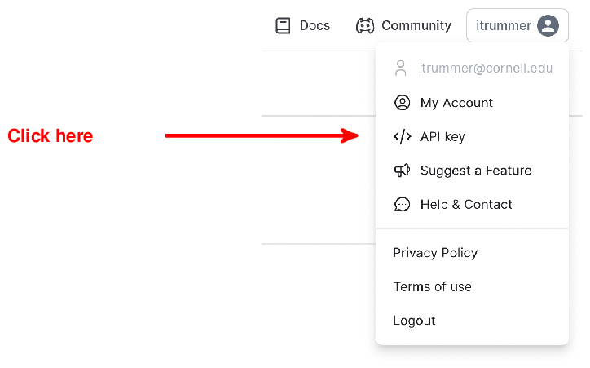

Up – understood.
Now, all it takes is a single invocation to get answers from Jurassic-1 (we will assume that prompt contains whatever prompt we want to submit):
result = ai21.Completion.execute(model='j2-mid', prompt=prompt)
copy
AI21 offers different endpoints for different types of tasks. Here, we simply use the Completion endpoint, submit the prompt and the name of the model we want to use (j2-mid refers to the medium-size version of Jurassic-2). We can access the text of the most likely completion by the following command:
result['completions'][0]['data']['text']
copy
With that, we have all we need to write a simple question answering application with Python. Listing 8.1 shows the full code (which you find as item “AI21 - 1” in the resource section on the book Website). Given the AI21 access key, as well as a question, as command line argu
Do you mean sai21generic.py?
ments, the code configures the AI21 via the access key , invokes the Jurassic-2 model for completion , and finally extracts (and prints) the model’s answer .

Listing 8.1 Answering questions via AI21’s Jurassic model using the Python API.
import ai21
import argparse

if __name__ == '__main__':

parser = argparse.ArgumentParser()
parser.add_argument('ai_key', type=str, help='AI21 access key')
parser.add_argument('question', type=str, help='Question to Jurassic')
args = parser.parse_args()

ai21.api_key = args.ai_key

result = ai21.Completion.execute(
model='j2-mid', prompt=args.question)

answer = result['completions'][0]['data']['text']
print(answer)

Up – code executes successfully
copy
To try it out, switch to the folder containing the code in the terminal and run, for instance, the following command (replace the three dots with your AI21 access key):
python ai21generic.py ... \
"What's the answer to life the universe and everything?"
copy
While the output is subject to some degree of randomization, it typically involves the number 42 (proving to Douglas Adams fans that the model is working correctly).
Ok, we can complete arbitrary text using AI21’s models! However, such generality is not always required. AI21 (as well as some of the other providers we discuss in the following) offers specialized models for standard tasks (e.g., summarization). If you want to solve one of the standard tasks, you may get a good tradeoff between processing fees and result quality by resorting to one of these. For instance, let’s say we want to paraphrase text, i.e., to express the same thing but with different words. AI21 offers specialized models to do just that. Here is how we can use such models (you find the code from Listing 8.2 as item “AI21 - Paraphrasing” on the book Website):

Listing 8.2 Using a specialized language model for text paraphrasing.
import ai21
import argparse

if __name__ == '__main__':

parser = argparse.ArgumentParser()
parser.add_argument('ai_key', type=str, help='AI21 access key')
parser.add_argument('text', type=str, help='Text to paraphrase')
args = parser.parse_args()

ai21.api_key = args.ai_key

result = ai21.Paraphrase.execute(
text=args.text, style='formal')

answer = result['suggestions'][0]['text']
print(answer)

Up – understood.
copy
The code takes as input the AI key and text to paraphrase. After configuring the AI21 library, we use the Paraphrase endpoint to paraphrase the input text . After that, we extract the answer and print it. You can try the code by running, for instance, the following command from the command line (you need to be in the folder containing the code):
python ai21paraphrase.py ... \
"Give me a cup of coffee!"
copy
Couldn’t we use the prior model to solve the same task, provided we include corresponding instructions into the prompt? Yes, we could indeed. The advantage of using specialized models is the price. E.g., at the time of writing, using the specialized paraphrasing model is ten times cheaper per token than the one we used in Listing 8.1. Have a look at https://www.ai21.com/studio/pricing for updated prices. If you find the output quality to be sufficient for your tasks, using specialized models may give you more “bang for the buck”!
Any comments on section 8.1 AI21?

Up – Good concise intro to AI21 with good supporting code examples.

8.2 Anthropic
Many of the stories by Isaac Asimov, one of the most prolific science-fiction authors of all times, center on the “three laws of robotics” and their interpretation:
- A robot may not injure a human being or, through inaction, allow a human being to come to harm.
- A robot must obey orders given it by human beings except where such orders would conflict with the First Law.
- A robot must protect its own existence as long as such protection does not conflict with the First or Second Law.
The goal here is to have a concise set of guidelines, making sure that robots are helpful and harmless. Whether or not the aforementioned laws provided any inspiration, this idea connects to the language models produced by Anthropic, yet another provider of large-scale language models.
Anthropic, founded in 2021 (by several former OpenAI members), has repeatedly touted the idea of “Constitutional AI” as one of the distinguishing factors, compared to other models. In a nutshell, this means that, when training models to provide users with accurate and non-offensive answers, we rely on a small set of rules, a “constitution” so to speak, to judge the quality of answers. Instead of relying on human testers to label answers generated by the model during training, we rather employ a second AI, charged with evaluating the answers of the former according to the constitution (for all details on constitutional AI, have a look at the corresponding paper).
At the time of writing, Claude 3 (a reference to the amazing Claude Shannon) is the latest model released by Anthropic. In the following, we will try out Claude via (you guessed it) a Web interface and a Python API.

8.2.1 Chatting with Claude
We will have quick a chat with “Claude” (currently in version 3) to get a first sense of its capabilities. First of all, go to the Anthropic Website at www.anthropic.com. You should see the Website shown in Figure 8.6. Click on the button that is highlighted in Figure 8.6.

Figure 8.6 The Anthropic Website: click on the button to interact with Anthropic’s Claude model.


Up – understood.
Unless you have created an Anthropic account before, you will be asked to provide an email address and ultimately a phone number. After verifying your data, you should see Claude’s chat interface, shown in Figure 8.7.

Figure 8.7 Web interface for Anthropic’s chatbot “Claude”.
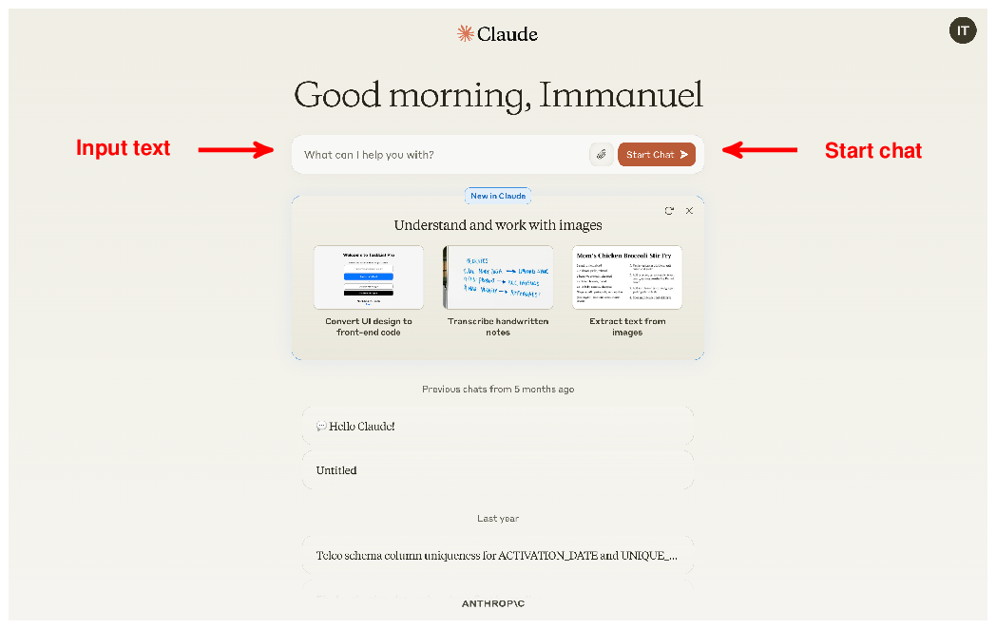

Up understood.
The interface is pretty intuitive: simply enter text in the corresponding field and click the button on the right to start chatting! Start with a friendly greeting, chat about the weather, or try using Claude to solve some of the tasks from (e.g., classifying reviews by sentiment or translating questions to SQL queries). One thing you might note, compared to other chatbots, is that Claude tends to be a little more careful in his answers, frequently pointing at its own limitations (e.g., for specific tasks such as writing SQL queries). That is in line with Anthropic’s philosophy of prioritizing safety. But don’t let Claude’s “modesty” fool you: when it comes to it, Claude is actually able to solve a variety of tasks (including writing SQL queries). It just might need a little bit of additional “encouragement” to solve your tasks.

8.2.2 Python API
Assuming you have created an account with Anthropic, you can create keys at the following URL: https://console.anthropic.com/settings/keys. Make sure to copy your access key after creating it (as you will not be able to access it again afterwards)!
After obtaining your access key, go to the terminal and run the following command:
pip install anthropic==0.28
copy
This will install the Anthropic Python library. If you are familiar with OpenAI’s Python library (and chances are that, after reading the previous chapters, you are!), you should get used to the Anthropic library very quickly.
For instance, Listing 8.3 shows Python code for answering questions using Claude. Of course, this code does not do anything that you cannot do via the Web interface. The purpose is just to show how easy it is to use Claude via the Python interface.

Listing 8.3 Answering questions with Anthropic’s Claude model.
import argparse
from anthropic import Anthropic

if __name__ == '__main__':

parser = argparse.ArgumentParser()
parser.add_argument('ai_key', type=str, help='Anthropic access key')
parser.add_argument('question', type=str, help='A question for Claude')
args = parser.parse_args()

anthropic = Anthropic(api_key=args.ai_key)

completion = anthropic.messages.create(
model='claude-3-opus-20240229',
max_tokens=100,
messages=[
{
'role':'user',
'content':args.question
}])

print(completion.content)
copy

Up – understood.
As input parameters , we are using the Anthropic access key, as well as a question we would like to get answered. Similar to OpenAI’s libraries, we configure access using the access key . After that, we can construct prompts for completion by Claude .
Using Anthropic’s anthropic.messages endpoint, we specify the ID of the model to use (claude-3-opus-20240229 is the newest model by Anthropic at the time of writing) and the maximal number of tokens for completion (using the max_tokens parameter). Similarly to OpenAI’s chat models, Claude is designed for chats between users and the model. Therefore, the input to Claude is a list of messages (containing only a single element in this specific scenario). We obtain the result of Claude’s prompt completion in the content field (which we print ).
You find the listing above as item “Anthropic” in the resource section of this chapter. To execute it, open your terminal and switch to the containing folder. Then, execute the following command:
python anthropic_claude.py ... "What is constitutional AI?"
copy
Substitute the three dots with your Anthropic access key. When executing the program, you should see an answer to your question, generated by Anthropic’s model.
Any comments on section 8.2 Anthropic?

Down – when running code I got this error:

Traceback (most recent call last):
File "E:\docs\book_reviews\manning\analyzing_multimodal_llms\chap8\anthropic_claude.py", line 19, in <module>
completion = anthropic.messages.create(
^^^^^^^^^^^^^^^^^^^^^^^^^^
File "C:\Users\gcart\AppData\Roaming\Python\Python311\site-packages\anthropic\_utils\_utils.py", line 277, in wrapper
return func(*args, **kwargs)
^^^^^^^^^^^^^^^^^^^^^
File "C:\Users\gcart\AppData\Roaming\Python\Python311\site-packages\anthropic\resources\messages.py", line 899, in create
return self._post(
^^^^^^^^^^^
File "C:\Users\gcart\AppData\Roaming\Python\Python311\site-packages\anthropic\_base_client.py", line 1239, in post
return cast(ResponseT, self.request(cast_to, opts, stream=stream, stream_cls=stream_cls))
^^^^^^^^^^^^^^^^^^^^^^^^^^^^^^^^^^^^^^^^^^^^^^^^^^^^^^^^^^^^^^^^^
File "C:\Users\gcart\AppData\Roaming\Python\Python311\site-packages\anthropic\_base_client.py", line 921, in request
return self._request(
^^^^^^^^^^^^^^
File "C:\Users\gcart\AppData\Roaming\Python\Python311\site-packages\anthropic\_base_client.py", line 1019, in _request
raise self._make_status_error_from_response(err.response) from None
anthropic.BadRequestError: Error code: 400 - {'type': 'error', 'error': {'type': 'invalid_request_error', 'message': 'Your credit balance is too low to access the Anthropic API. Please go to Plans & Billing to upgrade or purchase credits.'}}

This seems like I need to pay to run the script. To avoid incurring costs I’ll assume the code would have successfully.

8.3 Cohere
We quickly discussed hallucinations in . where? Essentially, a hallucination occurs if language models “make stuff up” since they don’t have access to data that is relevant to the task at hand. The Canadian startup Cohere puts a particular emphasis on avoiding such hallucinations by a method called grounding. Grounding the answer of a language model means linking it to real data, thereby reducing the chances of “creative” output, not based in reality.
Cohere supports a wide range of connectors, enabling Cohere’s models to access external data. For instance, Web search, as well as access to various databases is supported. Internally, Cohere accesses those data sources and provides the language model with information tailored to the request. But even better: Cohere shows you all data sources used to generate your answer. If you are the suspicious type (and, when it comes to answers of language models, you generally should be), you can follow up the references and validate that they support indeed the generated answer.
Let’s see how all of that works in practice. Time to chat with Cohere’s Coral model!

8.3.1 Chatting with Coral
At the time of writing, Coral is Cohere’s latest model. As usual, you can try it out via Web interface and use it via Python when processing large amounts of data. First, we’ll try the Web interface. For that, go to https://cohere.com/ where you should see the screen depicted in Figure 8.8. To try their models, click on the button that is marked up in the figure.

Figure 8.8 Homepage of Cohere (https://cohere.com/): click on the button in the right upper corner to try their language models.

Up - understood

What is RAG?
Figure 8.8 prominently advertises RAG but what was that again? RAG stands for Retrieval Augmented Generation. It means, that when generating an answer, we augment the input used by the language model with data we retrieve from an external source.
After signing up for an account, you should see the page shown in Figure 8.9. We’ll try Cohere’s Coral model. Click on the button marked up in Figure 8.9 to access the Web interface shown in Figure 8.10.

Figure 8.9 Click on the button on the bottom to try Cohere’s Coral model. Click on the upper button to see your API access key (which is required for the Python API).
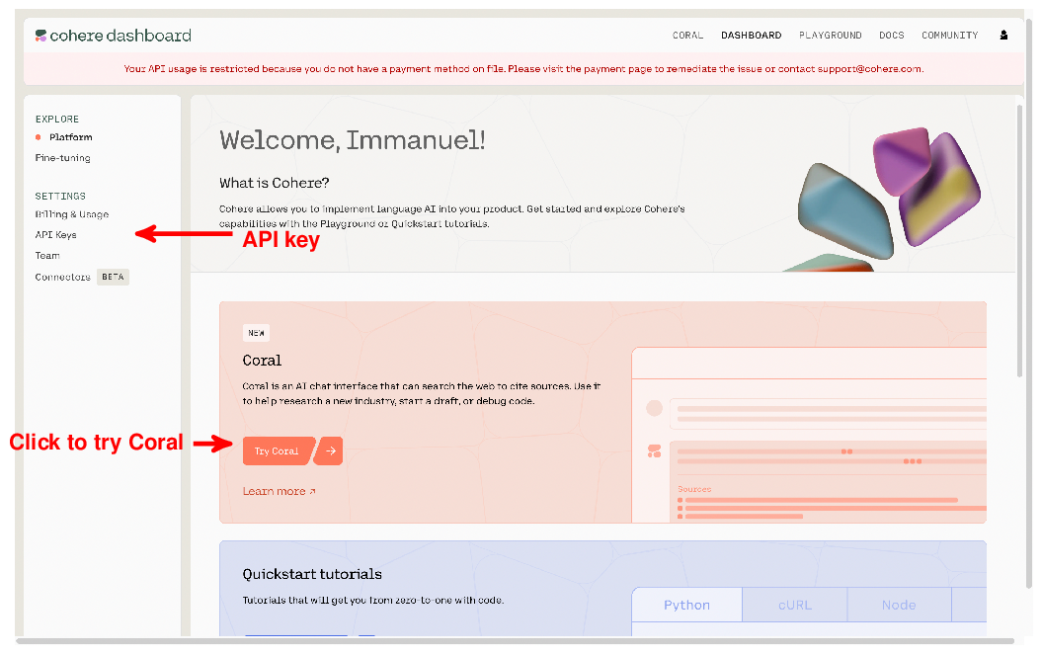
Up – understood.
Figure 8.10 shows where to enter your prompt. It also marks the button used to generate an answer. What about the window on the right (containing the button marked as “Web connector” in Figure 8.10)? This is where you specify connectors to use when generating your replies. A connector enables Coral to access external data sources. In Figure 8.10, we can activate (or deactivate) the Web connector by clicking on the button marked up in the figure. This connector enables Coral to query the Web, similar to what all of us would do when trying to answer a hard question that involves factual knowledge. Give it a try and see how the replies to factual questions change if the Web connector is activated or deactivated!

Figure 8.10 Web interface for chatting with Cohere’s language model Coral.
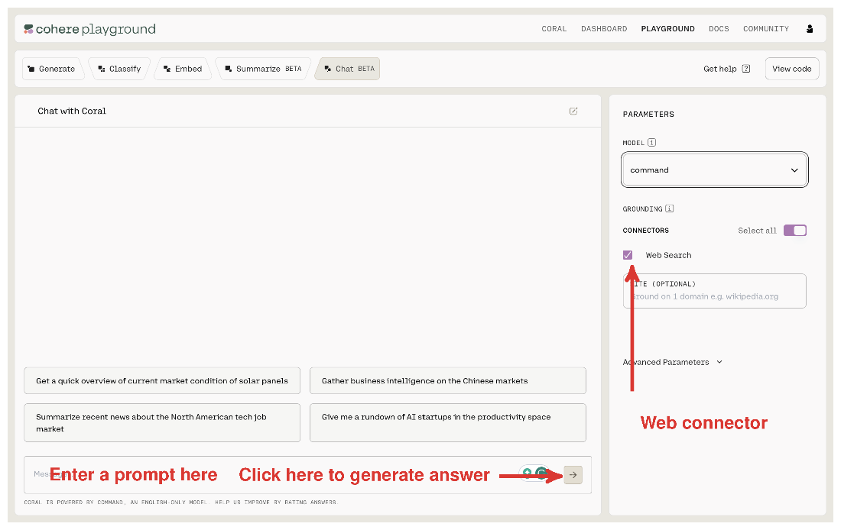

Did not see a PARAMETERS box.

8.3.2 Python API
Cohere offers a Python API, similar to the ones we have seen in previous sections. Enter the following command in the terminal to install the required library:
pip install cohere==4.43
copy
Listing 8.4 (which you find as item “Cohere” on the book Website) contains code for a simple question-answering interface. Users enter their access key a and a question on the command line. Have a look at Figure 8.9: it shows where to click in order to see your API access key. In Listing 8.4, after configuring the Cohere library with the access key , we generate an answer using the Cohere API . Note the reference to connectors in the call to the chat function! Here, we specify a list of connectors, enabling Cohere’s model to access data from external sources. Connectors are specified as a list (i.e., we can enable access not only to one but a multitude of connectors). In Listing 8.4, we use the connector with ID web-search (that’s the same Web search connector we used over the Web interface in the previous subsection).
Finally , we print the answer generated by the model but also a list of the Web sources consulted to generate the answer (along with the queries issued to retrieve those documents). That enables us to verify that the generated answer is indeed implied by the source material.

Listing 8.4 Answering questions via language models using Cohere’s Python API.
import argparse
import cohere

if __name__ == '__main__':

parser = argparse.ArgumentParser()
parser.add_argument('ai_key', type=str, help='Cohere access key')
parser.add_argument('question', type=str, help='Answer this question')
args = parser.parse_args()

client = cohere.Client(args.ai_key)

prompt = f'Answer this question: {args.question}'
result = client.chat(prompt, connectors=[{'id': 'web-search'}])

print(f'Answer: {result.text}')
print(f'Web searches: {result.search_results}')
print(f'Web results: {result.documents}')

Up – understood.
copy
Let’s try it out! Switch to the folder containing the code and run the command below in the terminal:
python cohereqa.py ... "Where was Steve Jobs born?"
copy
You will get an answer similar to the one shown in Listing 8.5 (which is slightly abbreviated).

Listing 8.5 Answer by Cohere’s Coral model with grounding.

Answer: Steven Paul Jobs was born in San Francisco, California, United States.
His birth name was later changed to Steve Jobs after
he was adopted by Paul and Clara Jobs.

Jobs was born to Abdulfattah Jandali and Joanne Schieble on 24th February, 1955.
After being put up for adoption, Jobs was adopted by Paul and Clara Jobs,
a lower-middle-class couple.

Web searches: [
{'search_query':
{'text': 'Where was Steve Jobs born',
'generation_id': '...'},
'document_ids': [
'web-search_1:0', 'web-search_3:1', 'web-search_4:0',
'web-search_5:0', 'web-search_9:1'],
'connector': {'id': 'web-search'}
}]

Web results: [
{'id': 'web-search_4:0', 'snippet': 'Short Biography of Steve Jobs
The story of Steve Jobs from cradle to grave - and beyond. Steven
Paul Jobs was born on February 24, 1955 in San Francisco, California.
... ', 'title': 'Short Bio | all about Steve Jobs.com',
'url': 'https://allaboutstevejobs.com/bio/short_bio'},
...]

Up -understood

copy
Let’s have a closer look. The initial part of the output is the answer generated by the model. The answer seems reasonable but can we trust it? This is where the remaining parts of the output come into play. The middle part provides us with information on the Web issued by Cohere to inform the generated answer. Those Web queries are chosen automatically, based on the input question. In this case, Web queries correspond precisely to the input question (this is not necessarily the case for longer input text). At the end of the output , we see text snippets, as well as the URLs, of the documents retrieved via the prior queries. In this case, text snippets taken from the Web documents (e.g., “Steven Paul Jobs was born on February 24, 1955 in San Francisco, California”) make a good case supporting the answer by the model.
Any comments on section 8.3 Cohere?

Prompt: E:\docs\book_reviews\manning\analyzing_multimodal_llms\chap8>python cohereqa.py … "Where was Steve Jobs born?"

Answer: Steve Jobs was born in San Francisco, California, USA.
Web searches: [{'search_query': {'text': 'Where was Steve Jobs born?', 'generation_id': '7ed139c4-d697-4b4e-a4fa-6cc52d1e838e'}, 'document_ids': ['web-search_0', 'web-search_1', 'web-search_2', 'web-search_3', 'web-search_4', 'web-search_5'], 'connector': {'id': 'web-search'}}]
Web results: [{'id': 'web-search_0', 'snippet': "History & SocietyScience & TechBiographiesAnimals & NatureGeography & TravelArts & CultureGames & QuizzesVideosOn This DayOne Good FactDictionary\n\nLifestyles & Social Issues\n\nPhilosophy & Religion\n\nPolitics, Law & Government\n\nBirds, Reptiles & Other Vertebrates\n\nBugs, Mollusks & Other Invertebrates\n\nFossils & Geologic Time\n\nEntertainment & Pop Culture\n\nVisual ArtsCompanionsDemystifiedImage GalleriesInfographicsListsPodcastsSpotlightSummariesThe ForumTop Questions#WTFact100 WomenBritannica KidsSaving EarthSpace Next 50Student Center\n\nIntroduction & Quick Facts\n\nLarry EllisonTable Of Contents\n\nAmerican businessman\n\nAlso known as: Steven Paul Jobs\n\nWritten bySteven Levy\n\nSenior editor, Newsweek, New York City. Author of Artificial Life: A Report from the Frontier Where Computers Meet Biology and others.\n\nFact-checked byThe Editors of Encyclopaedia Britannica\n\nThe Editors of Encyclopaedia Britannica\n\nEncyclopaedia Britannica's editors oversee subject areas in which they have extensive knowledge, whether from years of experience gained by working on that content or via study for an advanced degree. They write new content and verify and edit content received from contributors.\n\nUpdated: Sep. 08, 2024\n\nIntroduction & Quick Facts\n\nLarry EllisonTable Of Contents\n\nOpen full sized image\n\nSteve Jobs holding an iPhone, 2010.\n\nJustin Sullivan/Getty
.
.
.
showing how it’s all possible. See More\n\nEarl Sweatshirt’s birthday\n\nFloyd Mayweather Jr.’s birthday\n\nSteve Jobs’s birthday\n\nView all February holidays\n\nHolidays Straight to Your Inbox\n\nEvery day is a holiday! Receive fresh holidays directly to your inbox.\n\n6,286 Days celebrated\n\n18,858 Ways to celebrate\n\n1,000,000+ Happy users\n\nNational Today Calendar\n\nReviews and Gift Guides\n\nNational Girlfriend Day\n\nNational Boyfriend Day\n\nMexican Independence Day\n\nNational Best Friends Day\n\nNational Daughter Day\n\nAbout National Today\n\nWe keep track of fun holidays and special moments on the cultural calendar — giving you exciting activities, deals, local events, brand promotions, and other exciting ways to celebrate.", 'timestamp': '2024-09-03T17:53:16', 'title': 'Steve Jobs Birthday', 'url': 'https://nationaltoday.com/birthday/steve-jobs/'}]

It returned about 10 pages of his life story.

8.4 Google
Google, a company that needs no introduction, has been deeply involved with language models since the very beginning. In fact, the Transformer architecture, used by virtually all language models, has been invented (primarily) by Google researchers! No wonder that Google is developing its own models. At the time of writing, Gemini is one of Google’s most recent models and we’ll try it out in the following.

8.4.1 Chatting with Gemini
To try out Gemini, go to https://gemini.google.com/. After signing up for an account, you should see the interface depicted in Figure 8.11. Simply enter your text in the corresponding input field (marked up as “Enter prompt here” in Figure 8.11) and hit “Enter” to generate an answer. Gemini is not limited to text input. Click the button on the right to upload pictures. In your chats with Gemini, you can reference those pictures and ask questions about them.

Figure 8.11 Web interface for chatting with Google’s Gemini model. Click on “Settings” to activate additional functionality.
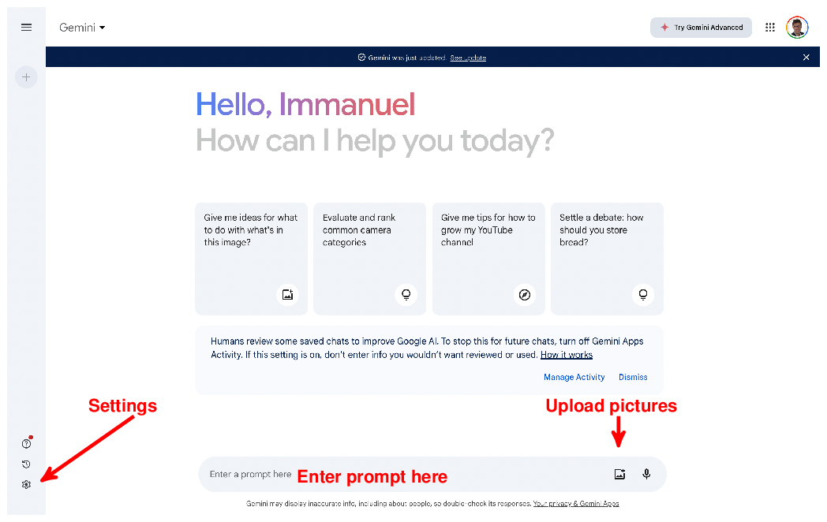

Up - understood
One particularity of Gemini, distinguishing it from all the other models we have discussed so far, is its integration with other Google tools. For instance, click on the “Settings” button (marked up in Figure 8.11) and then on the “Extensions” option to see the screen depicted in Figure 8.12. For instance, toggle the button marked up in Figure 8.12 to give Google’s Gemini access to your emails. Ever had the problem of finding information hidden in year-old emails in your inbox? Google’s Gemini has the potential to help with that.

Figure 8.12 Click to grant Google’s Gemini model access to your emails and other online data.
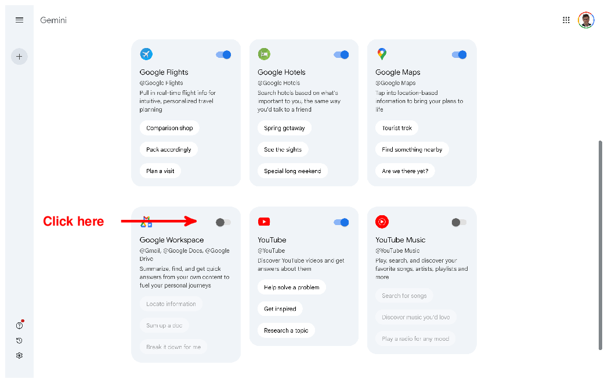

Up - understood

8.4.2 The Python API
Like other providers of language models, Google offers a Python API for model access. You can install the API using the following code in the terminal:
pip install google-generativeai==0.7
copy
Go to https://aistudio.google.com/app/apikey to get your access key for the Google API. Follow the instructions and copy the key right after creating it. Listing 8.6 shows how to use Gemini in Python for answering questions. The steps are similar to the previous API. The input parameters include the API access key (alternatively, we can store the API key in an environment variable) as well as the question to answer. Next, we configure the Google API with the access key . Now, we can generate a model and use it to answer questions via the generate_content method . Finally, we print out the generated question.

Listing 8.6 Answering questions using Google’s Gemini model.
import argparse
import google.generativeai as genai

if __name__ == '__main__':

parser = argparse.ArgumentParser()
parser.add_argument('api_key', type=str, help='Google API key')
parser.add_argument('question', type=str, help='Question to answer')
args = parser.parse_args()

genai.configure(api_key=args.api_key)

model = genai.GenerativeModel('gemini-1.5-flash')
reply = model.generate_content(args.question)

print(reply.text)

Up - understood
copy
You find the code above on the book Website using the link “Google”. In the terminal, change to the directory containing the code above. For instance, run the following command to test Gemini (replace the three dots with your Google access key):
The link to the Google code is incorrect.
python google.py ... "What is the meaning of life?"
copy
A full overview of Google’s API is beyond the scope of this book. However, knowing the APIs of other providers of large language models, you should be able to familiarize yourself quickly with this API as well.
Any comments on section 8.4 Google?

? after searching and finding code, it executed without issue

8.5 Huggingface
Providers like OpenAI invest millions of dollars to train models like GPT. The result of all that expensive training are values for model parameters that make the model perform best (have a look at for more details about model training). After investing all that money, you would not necessarily want to share the results of training freely, right? Hence, models like GPT are typically closed, meaning that OpenAI does not share the parameter values that result from training (note that OpenAI has shared other models such as “Whisper”). Instead, OpenAI processes your prompts for you on its own infrastructure, while charging you with a processing fee (that’s how we ultimately pay for all that expensive model training).
More and more, however, language model providers face competition from an extremely lively open-source sector. Universities, startup companies, and enthusiasts all train their own models and often release the models (and their parameter values) freely to the public! That enables you to run those models yourself, locally, on your own dedicated infrastructure. For smaller models, a laptop with a GPU would often suffice. For larger models, you might need to use a GPU cluster (or, you resort to Cloud providers again that run those open-source models for you). Besides potential financial advantages (running models on your own infrastructure may be cheaper), there are other considerations that could make running models locally the only viable choice. For instance, you may not want to trust external providers with particularly sensitive data. If you don’t want to send your data, running locally is the only option.
Typically, open-source models are significantly smaller than the models offered by Cloud providers. That makes sense since, after all, who has a few millions of dollars lying around to train a model? However, due to the sheer number of models that are available, it is often possible to find an open-source model that is specialized in solving just the task you’re interested in. For instance, the Huggingface Transformers platform features close to 500,000 Transformer models at the time of writing! Whatever task you are facing, chances are that you might find just the right model for you. In this section, we will have a look at the Huggingface platform and see how to use its models locally.

8.5.1 Web platform
Go to https://huggingface.co/. You should now see the Website shown in Figure 8.13. Huggingface Transformers offers various resources around Transformer models. That’s not only the models alone but also data sets you can use to train your own models as well as Cloud offerings, allowing you to run open-source models on Huggingface’s Cloud infrastructure. For the moment, we are interested in models. Click on the button marked up in Figure 8.13 to see the list of models, depicted in Figure 8.14.

Figure 8.13 Homepage of Huggingface Transformers (https://huggingface.co/). Click on the “Models” button to see a list of available Transformer models.


Up - understood
We’re seeing a list of 468,150 Transformer models (and, as the number of models is growing daily, you will probably see even a few models more)! Whew. That’s a bit too much, perhaps. Let’s narrow them down a bit. On the left side of the screen, you find various filter options to get the list down to the models you really care about. For instance, we can filter by the type of task we need the model to do. This includes text classification (e.g., classifying reviews by sentiment), visual question answering (e.g., does the picture show an apple?), and speech-to-text transcription (e.g., transcribing voice queries to text). For almost all of the tasks we discussed in this book, you may be able to find a specialized model. Simply click on any of the standard tasks to see only the models that solve this task.

Figure 8.14 Overview of Huggingface Transformer models. Click on the “Task filters” to narrow down the selection of models. Click on models in the “Model list” to see details.
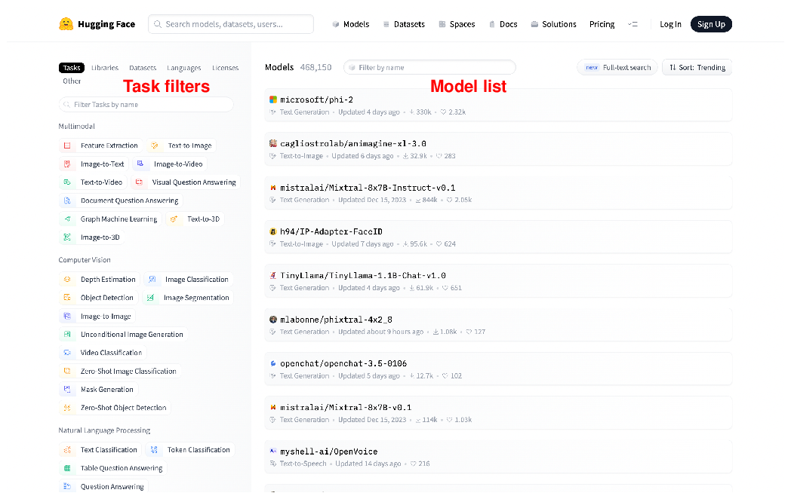

Up - understood
When clicking on one of the remaining models, you will see a detailed model description such as the one in Figure 8.15. Figure 8.15 shows details on the BLIP model from Salesforce, a model that processes images to generate suitable captions. On the left side, you find a thorough description of the model, links to relevant papers, as well as code samples, showing you how to use the model on different hardware platforms (i.e., locally). On the right side, you find an interface, that allows you to try out the model on a few sample pictures.

Figure 8.15 Detailed description of Saleforce’s BLIP model (https://huggingface.co/Salesforce/blip-image-captioning-large). Read the description on the left or try out the model via the interface on the right.
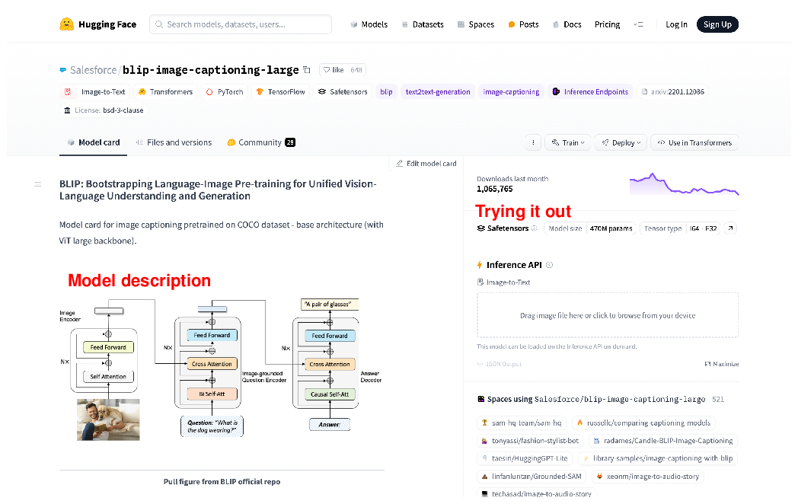

Up - understood

8.5.2 Python API
We are now about to run Transformer models on our own, local infrastructure! The performance you’re getting will, of course, depend on the properties of the hardware you’re using. However, even with moderate computation power, you should be able to work with the models we’re about to try. But, first of all, we must install the Hugginface Transformers library. Enter the following commands in your terminal:
pip install transformers==4.36
copy
The Transformers library is based on PyTorch, a popular machine learning framework. If you haven’t installed PyTorch yet, run the following command in your terminal (otherwise, you will receive an error message when trying to run the following code):
pip install torch==2.1.2
copy
That’s it for the setup! We’re ready to use the Huggingface Transformers library which we import via import transformers. The Transformers library offers a plethora of features and various ways to use the model in its repository (or to train your own models, for that matter). In this section, we’ll only cover a small subset of them but it’s enough to get a first impression!
Let’s assume you found a model in the Huggingface model repository that you would like to try out. To make things more concrete, let’s say we’re talking about the Roberta model for sentiment classification, offered by Cardiff University¹. Compared to GPT and most other models, discussed in this section, this is a fairly small model. However, the model is specialized for analyzing text to determine the underlying sentiment. While it is much less generic than GPT and similar models, it does one task and does it fairly well. If you are looking to classify reviews, for instance, you may find this model to be very suitable!
The easiest way to use a model via the Transformers library is via a pipeline. The command below creates a pipeline for sentiment classification, based on the aforementioned model:
1
2
sentiment_pipeline = transformers.pipeline(
model='cardiffnlp/twitter-roberta-base-sentiment-latest')
copy
As you see, we specify the model using the last part of its URL: the name of the account providing the model (cardiffnlp), followed by the ID of the model itself (which is twitter-roberta-base-sentiment-latest). When using the code above for the first time, the Transformers library will automatically download the model from its public model repository. Note that the code above works, in parts, because the model we are referring to is associated with a specific task class. For other models, we might have to specify the type of task we want them to solve as a separate input parameter.
We created a pipeline! Now we can use it to classify text, e.g., like so (we assume that the variable text_to_classify contains, you guessed it, the text to classify):
result = sentiment_pipeline(text_to_classify)
copy
We have all we need to build a simple application that classifies reviews (based on whether the underlying sentiment is positive, meaning a good review, or whether the sentiment is negative, meaning that the review is bad). Listing 8.7 shows the corresponding code (you find it as item “Huggingface” in the section associated with this chapter on the book Website).

Listing 8.7 Huggingface
import argparse
import transformers

if __name__ == '__main__':

parser = argparse.ArgumentParser()
parser.add_argument('review', type=str, help='Text of a review')
args = parser.parse_args()

sentiment_pipeline = transformers.pipeline(
model='cardiffnlp/twitter-roberta-base-sentiment-latest')

result = sentiment_pipeline(args.review)

print(result)

Up – understood.
copy
You might notice a first difference to all the code we have seen previously: we don’t need to specify any access key anymore! Since the Huggingface models are publicly available and since we’re running them on our own infrastructure, there is no need to provide any kind of credentials. Instead, the only input is a review text that we need to classify.
The code composes the snippets discussed before. It first creates a pipeline , uses it to classify the input text , and finally prints out the result. You can try it out by switching to the containing folder in your terminal and entering, for instance:
python huggingface.py "This movie was really awful!"
copy
When running the code for the first time, you might have to wait for a few minutes while the Transformers library is downloading the model you are referencing. But no worries: the library caches downloaded model such that you won’t have to wait anymore when running the code for a second time. After processing finishes, you should see output like the one below:
[{'label': 'negative', 'score': 0.9412825107574463}]

Up – code ran successfully, after running about 20 minutes the first time. Subsequent trial took about5 seconds or less.
copy
That’s certainly correct for the sample input shown above: the review is concise and 100% negative. Try it out with a few different reviews and compare to the output you’re getting with models like GPT! In the majority of cases, the classification result should be fairly similar. Of course, GPT is a much more generic model and can be used to solve a variety of other tasks as well. But, as long as you’re interested in classifying reviews, this model offers an interesting tradeoff between quality and costs.
Any comments on section 8.5 Huggingface?

Up – Great intro to Huggingface.

8.6 Summary
- Beyond OpenAI, several other providers offer large language models.
- Most providers offer closed-source models via a Cloud API.
- Models differ by their training focus, size and quality, and pricing.
- Some providers offer specialized models for tasks like summarization.
- Using specialized models can be more efficient for standard tasks.
- Most providers offer a Python API to access language models.
- Huggingface Transformers offers various models for free download.
- Many Huggingface models can be used via the pipeline object.
¹ https://huggingface.co/cardiffnlp/twitter-roberta-base-sentiment-latest↩︎
What did you think of this chapter?
hide feedback

1
How many stars would you give this chapter
5

2
What is your overall impression of this chapter?

This was chapter was well organized. There four different LLMs presented, but the author emphasized the similarities making it easy to move from one model to the next. Setup was well explained, though some interfaces did not match what the authored presented in the chapter. I think this can expected as LLMs and their web interfaces continue to evolve: but readers should be forewarned this may happen to reduce any degree of frustration this might cause. The presentation could have been enhanced with a ‘general’ diagram showing the py files shared a common data flow but include notations for specifics of each alternative.

This chapter should have ended with a table (or included in an appendix) comparing the previous models with alternative models, contrasting and comparing their capabilities and functionalities, costs, and best case uses.

